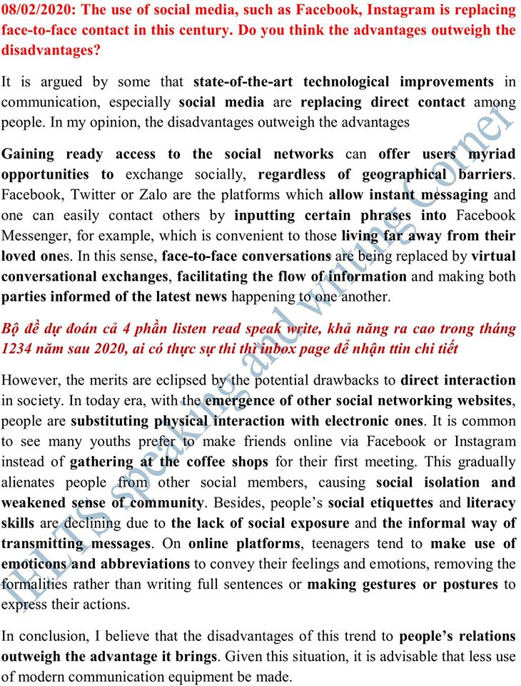

The use of social media is

First attempt

Thanks to advent of social medias, the world is closer than ever. However many people believe that social medias are driving direct conversation away from society in this era. In my opinion, its drawbacks seem to eclipse the benefits.

It is no doubt that social networking sites offer myriad opportunities to exchange socially regarless of geographical barriers.Some plattforms like Facebook, Instagram allow instant messaging, helping those who living far from their loved ones. Not only that do those sites provide communication services but they also keep their clients updated with the latest news. However, since information is not strictly regulated and controlled, cyber crimes can easily post fake news to scare people off.

With regard to disadvantages, traditional transmitting are being replaced by virtual conversation. In this century, people are choosing to make friends via social medias instead of following old traditional ways like meeting their first time at the coffee shops. Moreover, people are comfortable to stay at home rather than going out side and meeting new people, especially their local community.Therefore, society as a whole is becoming disjointed and fragmented.

Social medias have started adversely effect our life, they should be concerned as tools not ways we communicate.

Second Attempt

Thanks to the advent of social medias, the world is closer than ever. Besides their advantages, many people believe that they are driving people away from **direct coversation**. In my opinion, the drawbacks eclipse the benefits.

It is observed that social networking sites offer **myriad opportunities** to **exchange socially regardless of geographical barriers**. Some **plattforms** such as Facebook, Twitter **allow instant messaging**, which is crucial for those living far from **loved** **ones**. Not only do they provide distance communication they also keep their users **updated** with the **latest** **news**. However, information is usually not strictly controlled and regulated, so cyber crimes can post fake news.

With regard to disadvantages,the **virtual** **communication** is gradually replacing the **traditional trammit**. People become more confortable with making friends **via** social medias rather than face to face connections like meeting their first time at a coffee shop. It starts **advesely** effect our local community as people tend to stay at home instead of gathering up.Therefore, society as a whole is **disjointed** and **fragmented**.

In conclusion, social medias should be considered as a tools to help us connected but they should not define the ways we communicate.